Matthew Bell Game Developer / Tech Artist  Game developer who's self-taught & self-motivated with many years of experience across AAA, console, mobile and education. I have always had a strong interest in video games, in particular technical aspects involving lighting, rendering, shading and tools. My goal is to work with creative and ambitious studios on exciting projects. | mattbthe1st@gmail.com  urgrund.github.io/  /in/mattbell007

Singapore Art TD 2018-current
- Define art pipelines for key art assets (tracks, vehicles)
- Write shader set to be used with high performance in mind (mobile)
- Communicate technical restrictions to teams (Singapore/Malaga)
- Lead with examples of best practices with measured results
- Point of contact in both studios for art pipelines
- Regular profiling of project and reporting of any concerns
- Resulted in bringing low performing (memory/FPS) scenes up to targets
Singapore Lead Technical Artist 2016-2018
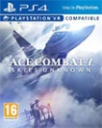  Ace Combat 7 | - Establish, promote and drive the technical goals of studio titles  - Stand in as acting lead artist/art director in-lieu of assigned staff  - Go-to person with outsourcing for technical guidance  - Re-working of core materials/shaders to align with performance targets  - Identified and pushed recruiting of some of the top talent still at the studio  - Assist HR with recruitment, relocation and on-boarding policies  - Assist management with studio direction and staffing structure
Singapore Senior Technical Artist 2015-2016
Assassins Creed Syndicate  Assassins Creed Origins | - Owner of data shaders for Singapore team focusing on usability and scalability  - Technical role managing the performance and budget cost of Xbox One & PS4 content  - Performance profiling with PIX/Razor  - Work with artist to build shaders/tech that supports visual benchmarks  - Establish myself as the go-to guy for technical and performance related questions for the art team
Abu Dhabi Head of Gaming Academy 2012-2015
The Gaming Academy is an initiative of twofour54 to help stimulate talent growth in the creative industries, in particular video games. I ran the course on both administrative and content delivery sides and managed stakeholder interest.
- Working relationship with Ubisoft Abu Dhabi staff to collaborate and manage involvement
- Integrated systems and procedures into the learning environment that mimicked a small development studio
- Designed, maintained and delivered curriculum with a flexible approach to maximize adaptability to current development practices
- Student progress and expectation management through review and consultation sessions
- Outreach efforts to local universities to promote the course and games development as a career opportunity
Brisbane, Australia Founder / Developer 2010-2012
Flame Shark was a mobile games start-up I began to enter the casual games market. The studio was alive for about 2 years though did not bring any products to an app store.
- Company registration/setup/reporting procedures
- Project documentation development and maintenance for technical, design and art
- Team management and task delegation
- Gameplay programmer role designing and implementing gameplay mechanics in C#

Brisbane, Australia Lecturer / Tutor (part time) 2010-2012
- Student mentoring and consultation on projects and assessment
- Student grading and marking in line with the provided curriculum
- Development of lecture and tutorial/workshop content

Singapore Assistant Technical Art Director 2009-2010
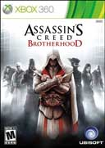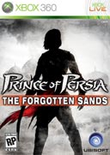Assassins Creed : Brotherhood  Prince of Persia  Assassins Creed 2 | - Performance of AAA content on Xbox360 & Playstation 3 consoles  - Daily profiling of performance concerns with environment/fx data  - Educate and delegate performance tasks to art team  - Introduce new staff to internal tools, technology and processes at Ubisoft  - Establish myself as go-to guy for technical and performance related concerns  - Surgical scene deconstruction (using PIX and other tools)  - Lighting role on many environments to assist art team with milestones  - Environment artist role (textures, mesh, lighting, profiling)  - Pre-production work on ocean shading technology for Assassins Creed 3

Brisbane, Australia Lead Environment/Tech Artist 2006-2009
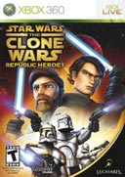 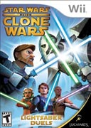 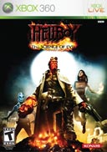Star Wars : Republic Heroes  Star Wars :Lightsaber Duels  Hellboy :The Science of Evil | - Environment art roles taking on daily tasks of architectural and landscape construction  - Lead role managing team of environment artists  - PlayStation 3 / Wii / Xbox360 development  - Profiling to expose areas of low performance and delegation of tasks to rectify  - Authoring of shaders and required materials and textures when needed  - Generalist role (props/textures/lighting) as the projects required
Melbourne, Australia Environment/Tech Artist 2004-2006
Tribal Clash  Retribution | U235 was a small start-up studio in Melbourne, Australia. Due to the very small team size I took the initiative to learn technologies where these skills were absent from the team. After a pitching round in Lyon, France was unsuccessful we ceased production.  - Took ownership of C# and shaders due to lack of staff to cover  - Pitched in Lyon, France with Producer to potential investors at Game Connect 2005  - Responsible for all art and managed/mentored other staff members  - Managed outsourcing of assets with reviews and quality control
Brisbane, Australia Environment Artist 2003-2004
Secret Service 2 | First foray into the professional realm of the games industry! This was a low-budget studio charged with developing an Activision Value game. My role as an environment artists included the modelling and surfacing of world props and geometry including material creation (and all maps required). In the closing months I was also tasked with AI setup and lighting.

Education & Skills

University of Queensland CSEE 2004
Bachelor of Information Environments

Visual | Technical | Project
- 3D and 2D content creation  - Game art pipelines  - Strong environment art skills  - Good eye for colour and shape  - Experienced in 3dsMax/Photoshop  - Strong art optimisation skills | - C# gameplay/tools  - Shaders  - Problem solving  - Lighting  - Performance Profiling  - Rendering pipeline | - Team Management in Lead roles  - Task delegation  - Training / Lecturing experience  - SVN/source control  - Task tracking and delegation

Extra Activities
Hobby Projects
As video game development is not just a day job for me, I am constantly engaging myself in personal projects. This keeps my skills fresh whilst allowing me to explore certain areas of development that may not be part of my primary duties at work. These projects may range from an environment scene to small prototypes in Unity.
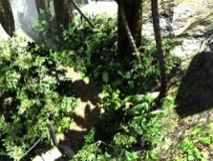 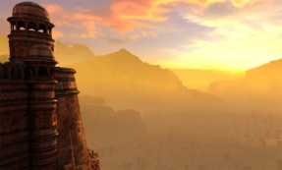 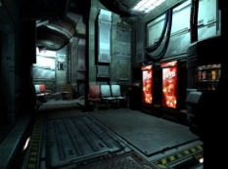
Photography
Photography is an activity I actively engage in as I find it offers both relaxation and excitement depending on what you are trying to capture. Pursuing this hobby both technically and aesthetically has toned my digital art skills as it helps me to appreciate object form, silhouettes, lighting and framing which, in games development, translates directly to scene quality with regards to those aspects.
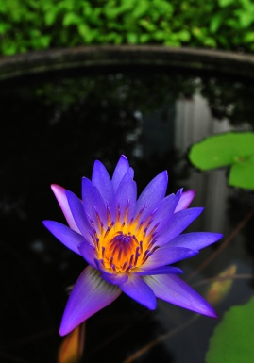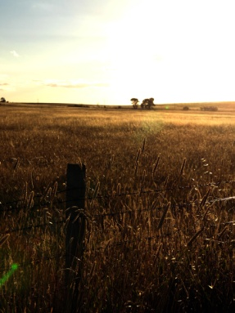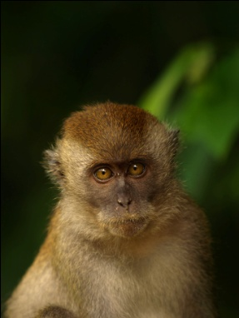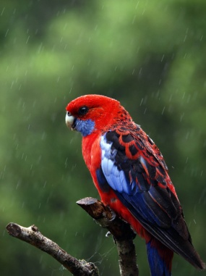
Auto-Mechanics
I began to have an interest in mechanics about 2007 and subsequently purchased a roaring V8! I found the technical challenges involved with fixing problems, albeit small, was fun and engaging and I often found many parallels with combustion engine design and game engine design! I guess the principles of engineering hold true in most fields where they are applied!
Music
Music has been a part of my life for many years with my mother being a music teacher. I play a few instruments and have played in many bands often touring and recording with them. My instrument of choice is drums and I continue to get practice in when I can.
Gaming
I’m regularly enjoying playing through games, though not as frequent as I used to! Nowadays, I find I will pick certain titles and then really exhaust what they have to offer – I want to experience everything the team may have wanted the player to discover. The below platinum achievements demonstrate this. As a game developer, getting through to 100% on such titles allows you to study the games’ mechanics and progression as well as the efforts put into the art.

God of War NG+
Dark Souls III + DLC
Bloodborne + DLC

